Viewing Schedules using the CNRO Alayacare Web Version of the Portal.

The Web Version of the portal gives you more options to view schedules.

 | Web Version | Mobile App
Access | Google Chrome | Download the app
Your schedule
Daily
Weekly |  | X
Monthly |  | X
Client’s schedule
Daily |  | X
Weekly |  | X
Monthly |  | X

Step 1 – Open your browser
- Google chrome works best but you can also use Safari or Microsoft Edge
- Enter the following website URL in the browser and press enter to go to the Login page
  - cnro.alayacare.ca

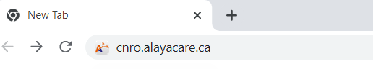

Step 2 – login
- using the same email address and password as you use for the mobile app.

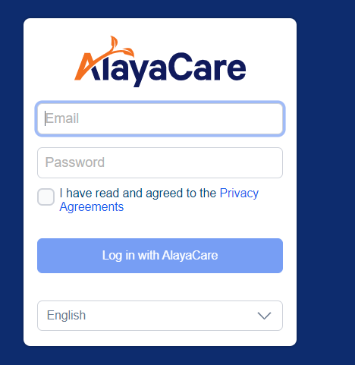

Features of Your Alayacare Website Profile

Your profile opens to your schedule today.
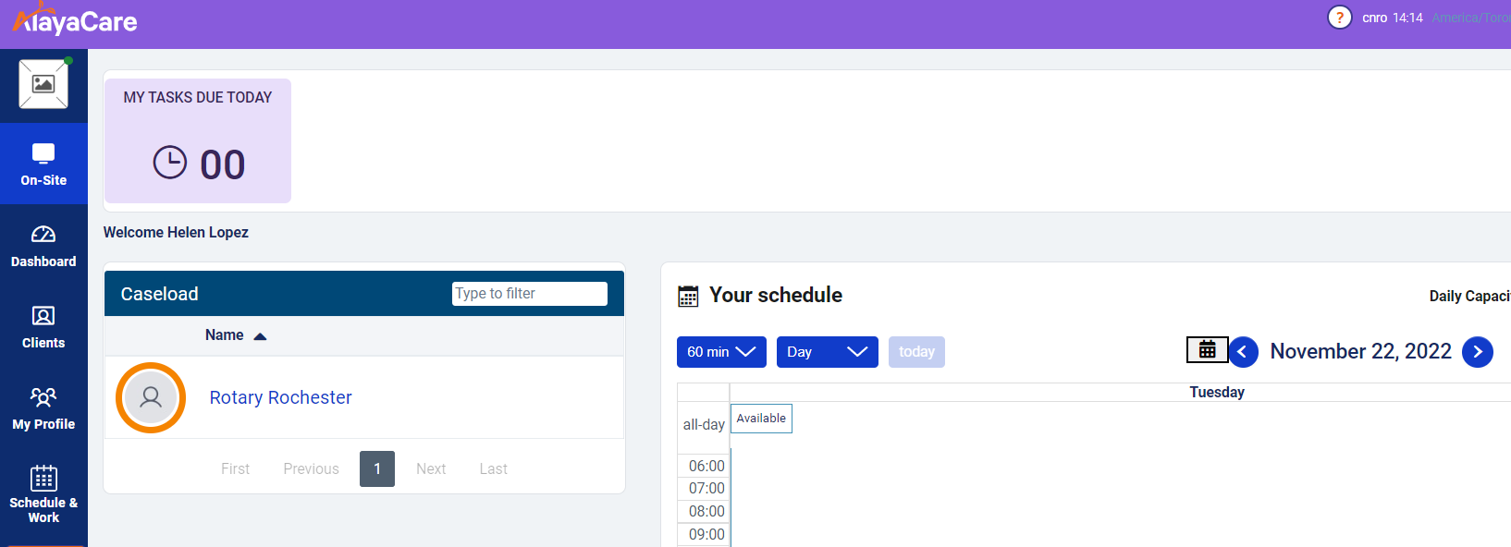
Tap your client’s name to access their full schedule.

The default is a day view. You can change to a month view to see the full schedule.
Tap the arrows to move between months
Tap the down arrow to change the schedule view to Week or Month
Your clients
Your name

