Medication Administration in the Alayacare Mobile App

Refer to the following link to view the instructions for administering, editing or adding medications in the Alayacare mobile app.

https://alayacare.zendesk.com/hc/en-us/articles/224231248-How-do-I-view-add-edit-administer-a-medication-on-mobile-

Note: The process is the same for Android and Apple phone, but the screens are slightly different. The screenshots in the above link are primarily for android devices. For Apple devises see the screen shots below.

Notes for all versions
- The date and time of administration is not editable. The administration time will be the time you’re recording the administration and not the time you gave the medication.
- Best practice is to document medication administration as close to administration as possible.
- If you are unable to document within 45 minutes of the scheduled administration time;
  - Document the administration in the mobile app
  - Write a progress note providing the actual administration time, indicating the note is a Late Entry.

Administering a medication
- In your schedule, tap on the visit to open the client profile.
- Scroll across the client dashboard to the MEDICATION TAB

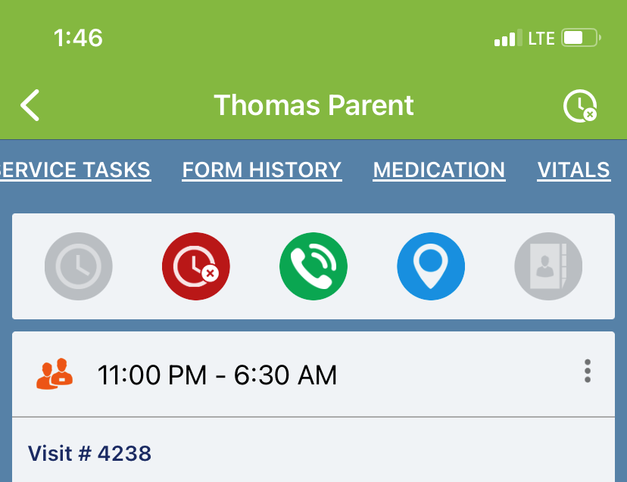

- Tap the Medication tab to open the medication list and tap a medication field to see the full order.

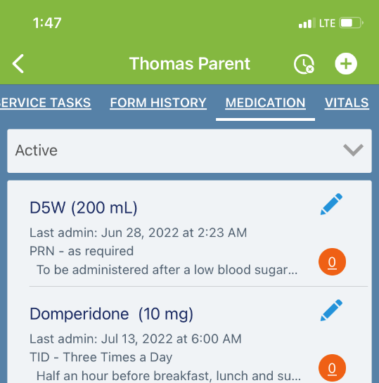

Tap ADMINISTRATIONS to administer the medication as ordered (Apple view)
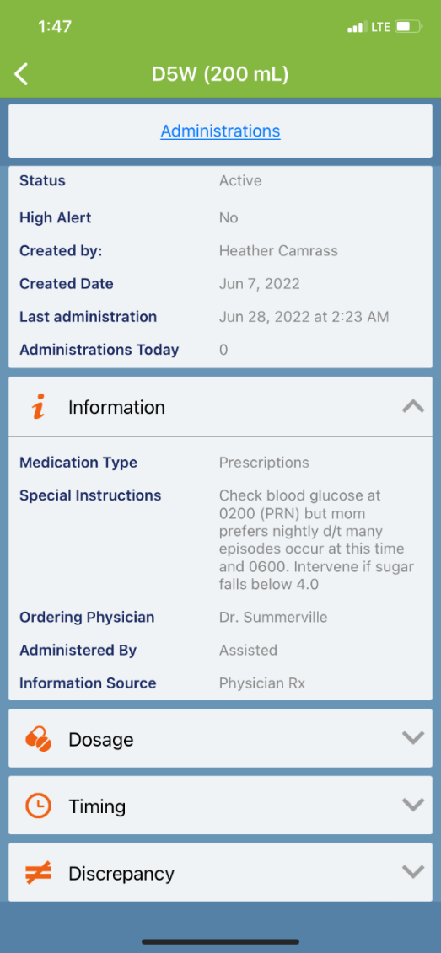

Once you tap Administrations, you’ll see the dates/times the medication was last administered. Tap ADMINISTER to take you to the next screen. (Apple view)
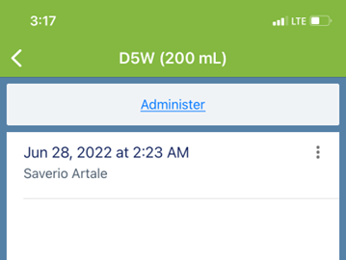

The medication and dose you’ve administered is at the top of the screen.

Click submit to record the administration.

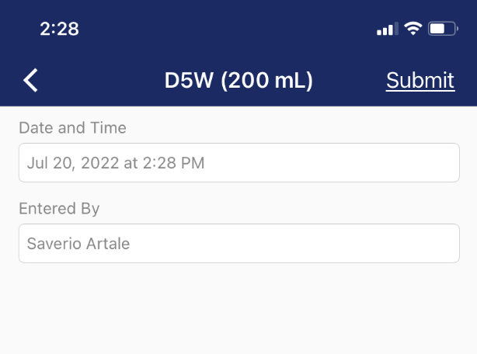
Your name

Editing or discontinuing a medication in the Alayacare app

Medication orders cannot be edited. If there is an error in the order, the order must be discontinued an re-entered correctly.

- From the medication list, tap the pencil icon for the medication you need to edit or discontinue
- The next screen will have the details of the order.

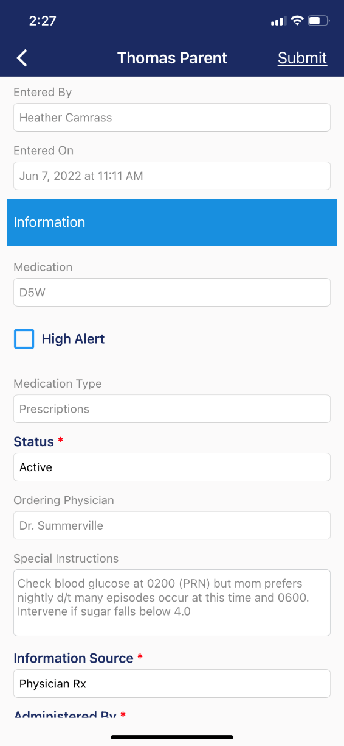

- Select the appropriate status

- Enter the new medication order.

Entering a new medication

- From the clients list of medications, click the icon (top right hand corner)
- 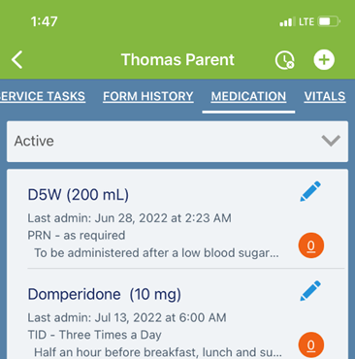

- Complete the fields to create a new medication.

