Location of Forms in the Alayacare Mobile App

The client forms have been moved off of the client dashboard and are now located together in the Forms History tab on the mobile app.

- Log into the app and tap on the visit to open the client profile.
- Clock into the visit as you would normally.

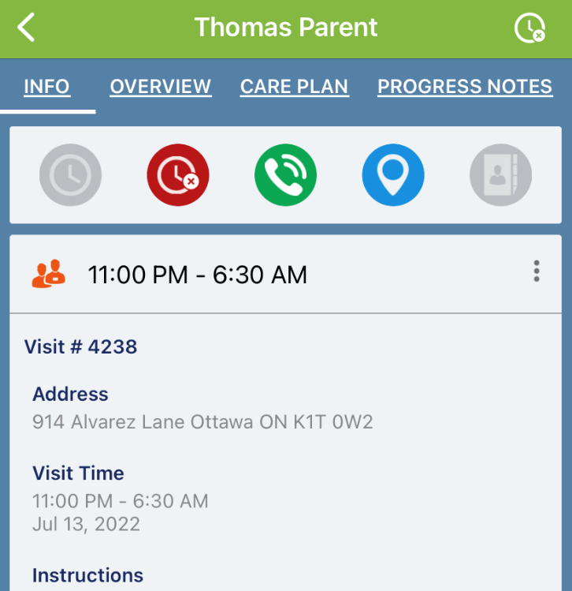
Client Dashboard

- Once the visit is opened, scroll across the dashboard from right to left until you see Forms History

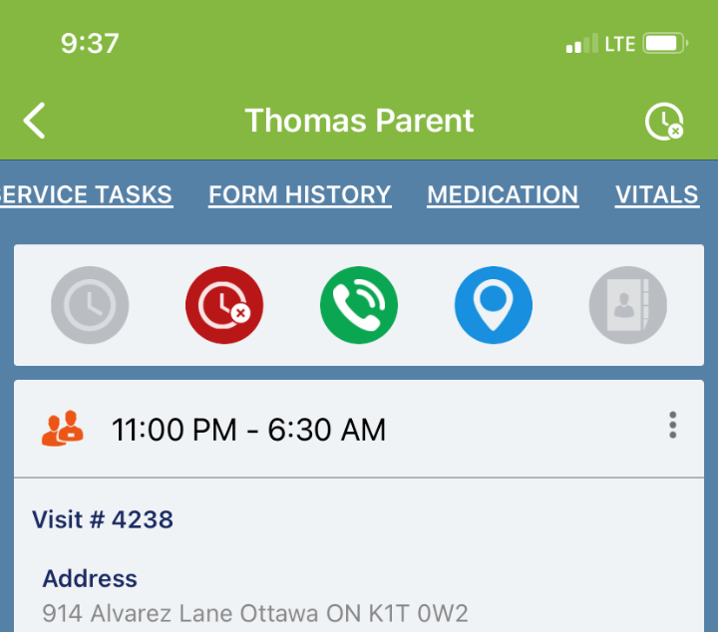
- Tap on Form History to select this screen.
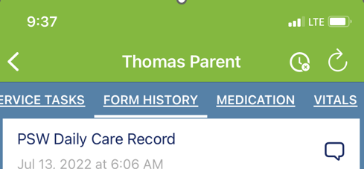

- You will see a list of previously submitted forms for the client. Tap on the symbol to access the list of forms available.

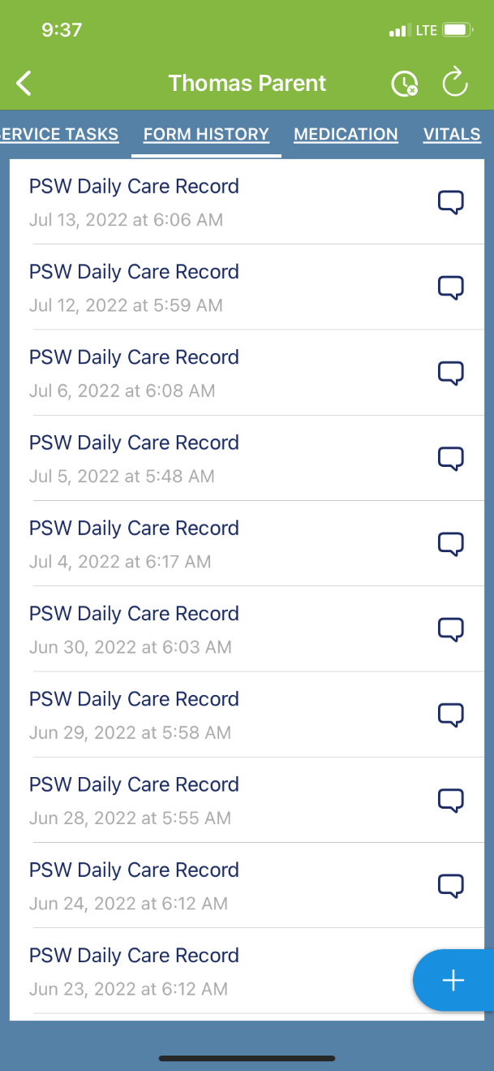

- Select the form you wish to complete and complet and submit as usual.

