AlayaCare Mobile App Set-up and functions for Members

Install the AlayaCare App

1. Download the AlayaCare app on your smart phone or tablet. Open the app when the download is completed.

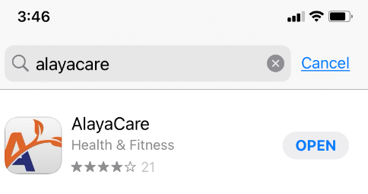

1. Enter the CNRO Server name when prompted:

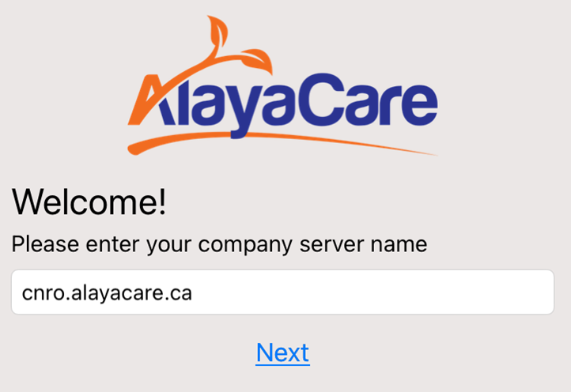

**cnro.alayacare.ca**

1. Allow access to location while using the app – this will allow you to find directions to your client’s home.
2. To log in enter the following:
   1. User ID: Your email address
   2. Enter your initial password – Cnro2022

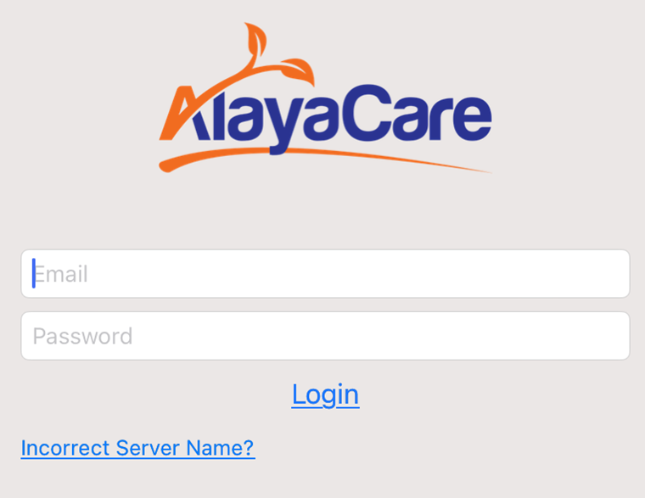

1. Review the privacy agreement and select “I Agree” to access your profile and site.
2. Once you logged in once, your email address will be saved and you should only have to enter your password each time you log in.
3. The first screen you see will be your schedule today.

Navigating the Mobile App

1. Click the Menu Icon Ξ (upper left corner) to see the app options.

* Caseload for a list of your clients
  + You can scroll through the list or use the search bar to find your client.
* Schedule – shows your daily schedule
  + Scroll left or right to move from day to day in your schedule.
* Open activities - to view a list of open sessions (visits) or uploads
  + This is your go-to place if you’re not able to clock into a scheduled visit.
* Offers – CNRO is currently not using this function
* Tasks – To see specific tasks related to a client.
  + This may be something the client wants done or an SPR to be completed.
* Logout – to end your mobile app session
* Settings –
  + Change your password
  + Set up FACE ID to log into the app if you have this feature on your phone.

Getting Started

1. Log into the mobile app
   1. Using your email and password
2. Clock-in to a visit.
   1. In your schedule, tap on the client visit
   2. At the beginning of the visit, tap the GREEN Clock-in Symbol
      1. You will be prompted to respond to the 4 Covid questions before you are able to access the client file.
      2. If you answer no to all the questions you will be asked if you want to continue clocking in.
   3. You will now be able to access all aspects of the client record.
   4. At the top of the screen, you will see the **clients name** and the dashboard menu.

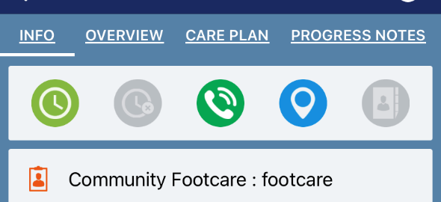

Tap to call the client

Dashboard

Tap to access the map map

Clock in

1. Use the Dashboard menu to access the various components of the client chart. Swipe from right to left to see the following links
   1. INFO tab -tells you which service(s) the client is receiving
   2. 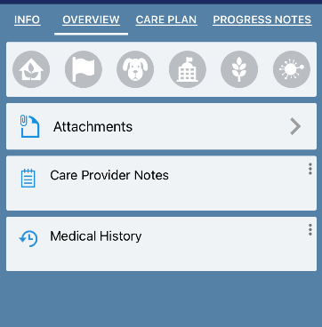OVERVIEW TAB

The icons at the top give you information about any risks that may exist in the client’s home.

* + 1. Grey means no risks identified
    2. Click on any coloured icons to get information about the RISK identified about the client, their family or their home.
    3. Tap on ATTACHMENTS to see any attachments included in the client file.
    4. Tap on CARE PROVIDER notes that will give you important information about the client, their medical history, accessing their home etc.
  1. CARE PLAN – Goals and interventions for care
  2. PROGRESS NOTES – go to this tab to enter and review narrative notes
     1. When you open this tab you will see any previous notes
     2. To create a new note, scroll to the bottom of the page and tap the + sign

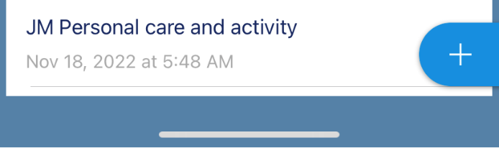

1. Tap anywhere in the open field to bring up your keyboard

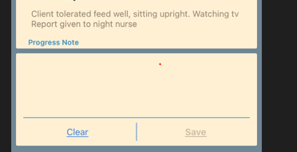

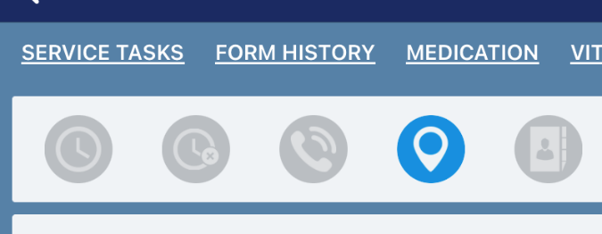

* 1. Service tasks – not something we will use frequently but if there is something specific the client wants done we may put it there.
  2. FORM HISTORY
     1. This is where you will find forms such as Flow sheets or SPRs housed.
     2. The tab opens to forms that have already been completed.
     3. Click the  located bottom right of the form history screen to bring up the list of available forms and select a new form for completion.

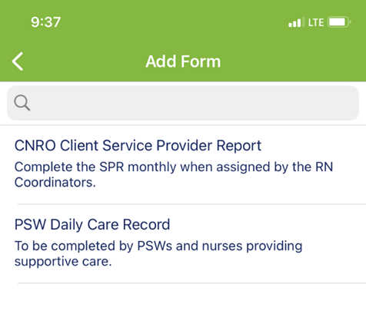

* 1. MEDICATION
     1. If you are entering medications in Alayacare, tapping on this tab opens the list of active medications and forms the MAR for documentation of medication administration.
     2. The dose, frequency and time of administration is included.
     3. To administer a medication, tap the medication name and submit if there are no changes.
        1. Select hold
        2. NOTE: The time reflected on the MAR is the time you are documenting the medication. Late entry notes are required in the comment field if you document the administration later in the day.
        3. Best practice is to document medications as you give them.
     4. See the Medication Handout for specific directions on administering medications.
     5. Nurses can add medications on the mobile app. See the Medications Handout for specific instructions.
  2. VITAL SIGNS
     1. Tapping the Vital Signs tab will take you to where vital signs are recorded and documented.
     2. 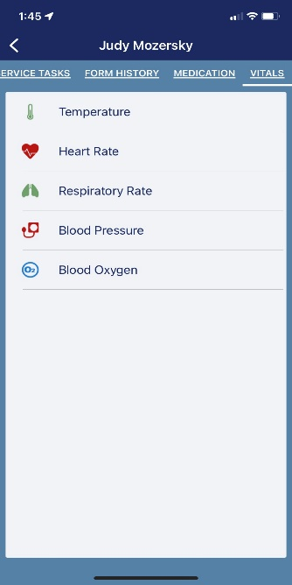
     3. The vital signs profile for each client is individualized for the client. You won’t see measures not relevant to the client’s normal care profile.

Clocking out of a visit

At the end of the visit scroll back to the INFO tab on the Dashboard and tap the RED Clock-out Symbol to close the visit.

Tips and Tricks

1. If your screen looks like any one of the following images, it means you are still clocked in a previous visit and won’t be able to clock in until you clock out for that visit.

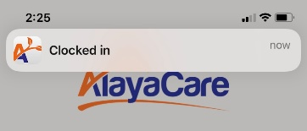

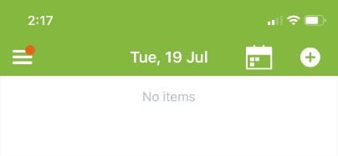

1. If you don’t have a green clock when you open a visit, it means you haven’t clocked out of a previous visit.

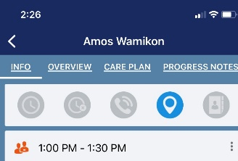

1. If you can’t clock into a visit take the following steps to solve the problem
   1. Tap the menu icon Ξ (upper left corner of your screen) to return to the main menu
   2. Select Open Activities to go the screen below.

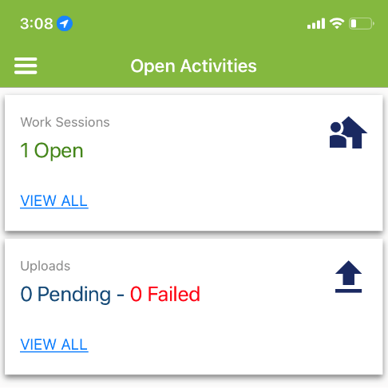

This means you have not clocked out of a previous shift. Tap View All to go to the shift

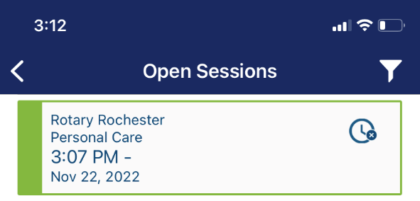

Tap on the shift and clock out as per the instructions above.