Re-Installing the AlayaCare Mobile App

Install the AlayaCare App

1. Download the AlayaCare app on your smart phone or tablet. Open the app when the download is completed.

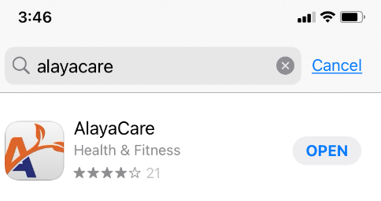

1. Enter the CNRO Server name when prompted:

**cnro.alayacare.ca**

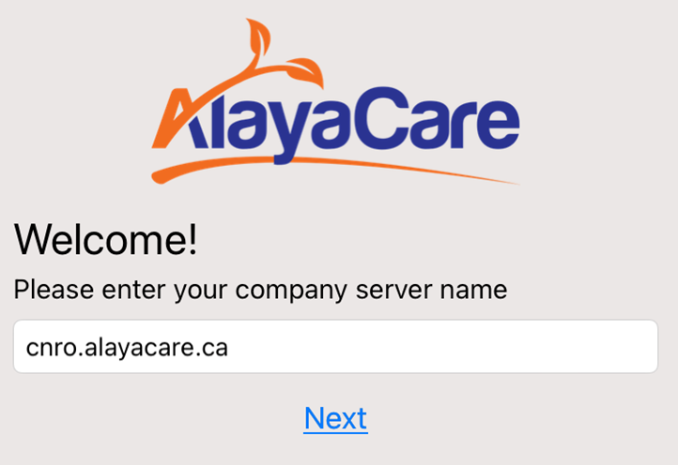

1. Allow access to location while using the app – this will allow you to find directions to your client’s home.
2. To log in enter the following:
   1. User ID: Your email address
   2. Enter your initial password – Cnro2022

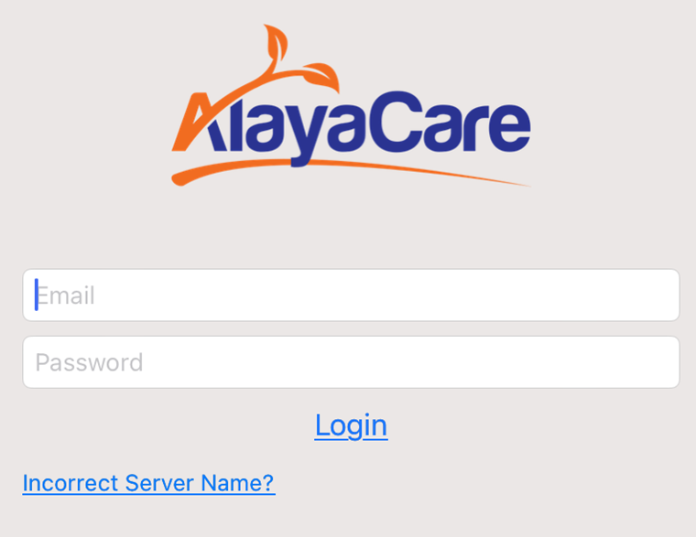

Your current password

Your email address

1. Review the privacy agreement and select “I Agree” to access your profile and site.

Tips and Tricks

1. If your screen looks like any one of the following images, it means you are still clocked in a previous visit and won’t be able to clock in until you clock out for that visit.

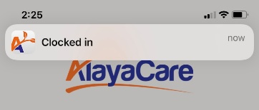

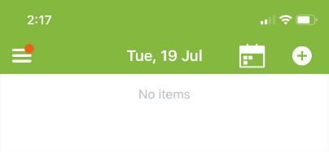

1. If you don’t have a green clock when you open a visit, it means you haven’t clocked out of a previous visit.

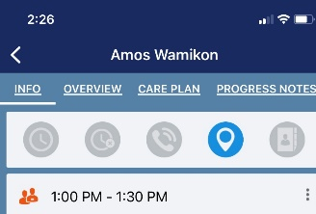

1. If you can’t clock into a visit take the following steps to solve the problem
   1. Tap the menu icon Ξ (upper left corner of your screen) to return to the main menu
   2. Select Open Activities to go the screen below.

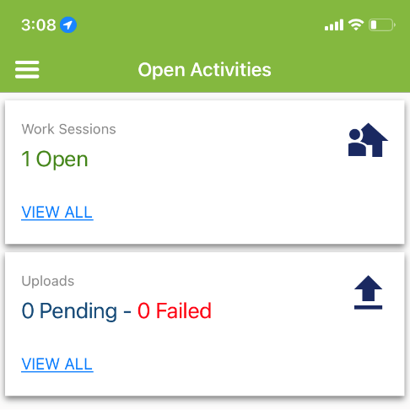

This means you have not clocked out of a previous shift. Tap View All to go to the shift

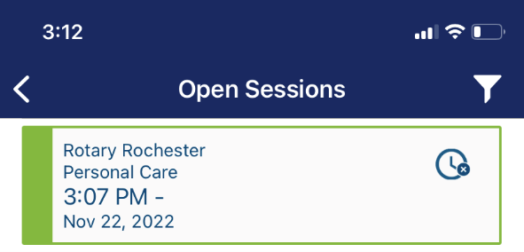

Tap on the shift and clock out as per the instructions above.