COVID 19 Standard Procedures for CNRO Members

- CNRO does not recommend any travel outside the Ottawa area during this period. If you must travel, we expect you to voluntarily disclose your plans. Be aware that following all travel you will not be able to work with CNRO clients for 14 days after you return from your trip.

- If you develop symptoms please call us as soon as you have symptoms and don’t wait until your next shift to tell us you’re unwell. Member availability may be limited over the next several weeks and we will need as much time as possible to cover absences.

- Screen your clients and families before going in for your shift. CNRO has put screening tools on the website for you to use.

- If you are going to a CNRO client after working in another facility, we recommend you bring a change of uniform/clothes to reduce the risk of viral spread.

- Frequent hand washing while in client spaces is important to reduce the spread of COVID 19. Soap and water is still the best method for washing your hands. CNRO recommends carrying bar soap and paper towels as part of your work kit to ensure you can safely perform hand hygiene as needed.

- Maintain a reasonable distance of 1 metre between other team members, family members or visitors to reduce the impact of droplet spread.

- Clean high touch surfaces frequently including
  - Wheelchairs and assistive devices
  - Feeding pumps
  - Bed side rails
  - All remotes
  - Bathroom and kitchen surfaces
  - Door knobs

- Limit unnecessary visitors and ask any visitor to leave if you have concerns.

Basic COVID 19 Information

- COVID 19 is highly contagious. The main mechanism of spread is through droplet or direct contact with the virus. Hand hygiene with soap and water is the best mechanism to reduce spread.
- Maintain a distance of 1 metre (or 3 feet) between others to reduce the impact of droplets.
- Contact Public Health Ottawa if you have any questions regarding the need for screening.

COVID 19 Symptoms
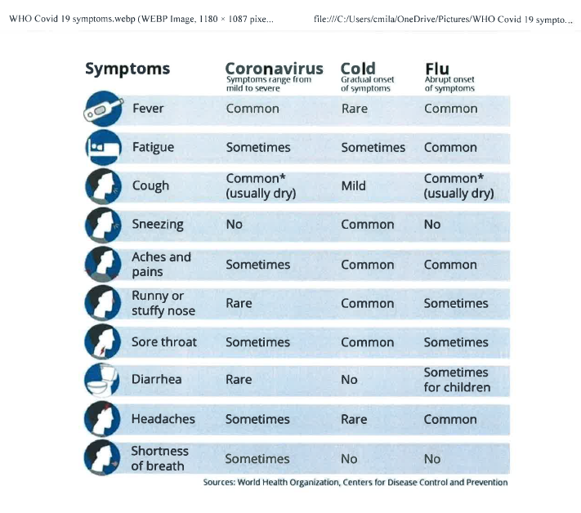

Important Resources

Ottawa Public Health 613-580-2424 https://www.ottawapublichealth.ca/en/index.aspx

Province of Ontario https://www.ontario.ca/page/2019-novel-coronavirus

