Step One:
- Open the CNRO website www.cnro.ca and click on the members tab to open the My Profile sign in page.
- Enter your email address and the password Carolyn or I sent you.
- If you don’t remember the password use the “Forgot Password” link to reset your password.

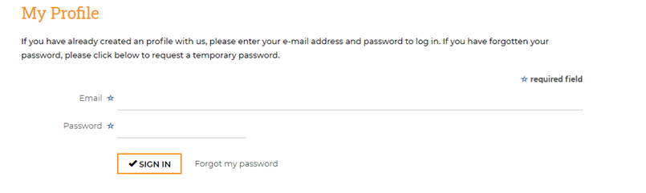

Step Two:

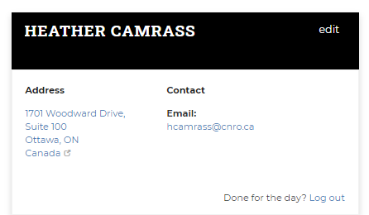
- Go to the Your Timesheet column and click ‘View All”
- The Your Timesheet column will be empty until you enter your first invoice.
- All the invoices you submit will be saved in your profile.

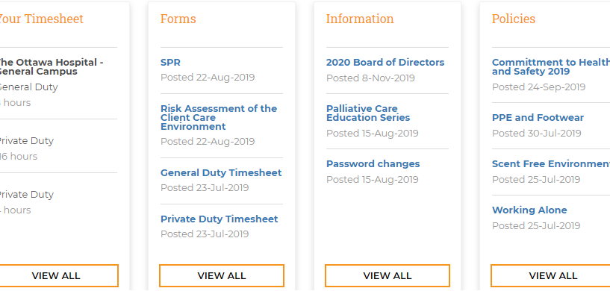

Step Three:
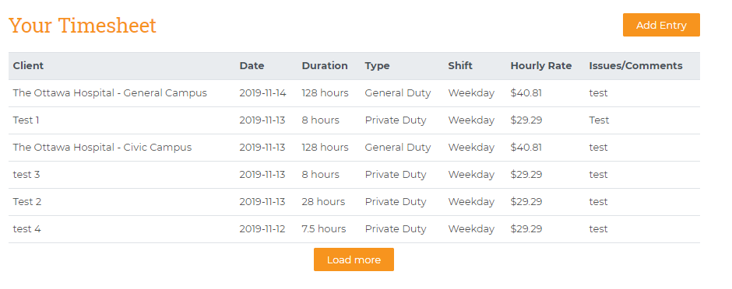
- Click Add Entry to enter a new invoice
- Your name has been linked to your Existing clients.
- Start typing the client/facility name in the dropdown box to get the full list.
- If you accept a new client, enter the name in the NEW PATIENT/FACILITY line. You will not get a drop down until we link your name with the new client.
- Compete the rest of the required information
- Double check that you have your hours and client entered correctly and click SUBMIT at the bottom.
- NOTE: You cannot make any changes after you click submit.
- If you make a mistake, email Louise and she will make the correction.

