Password Change Instructions

- Click on the members button on the CNRO website

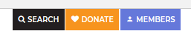

- Log in with your email address and current password

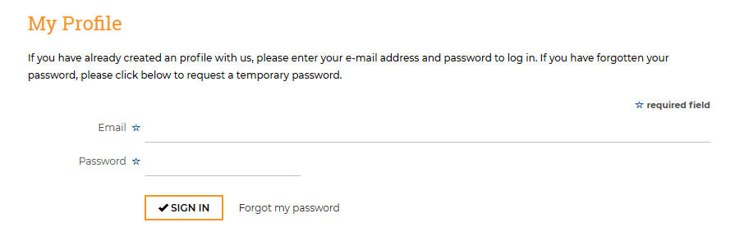

- Select Edit to the right of your name.
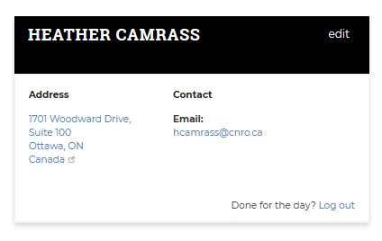

- In the change password field, enter your new password. Re-enter in the confirm field
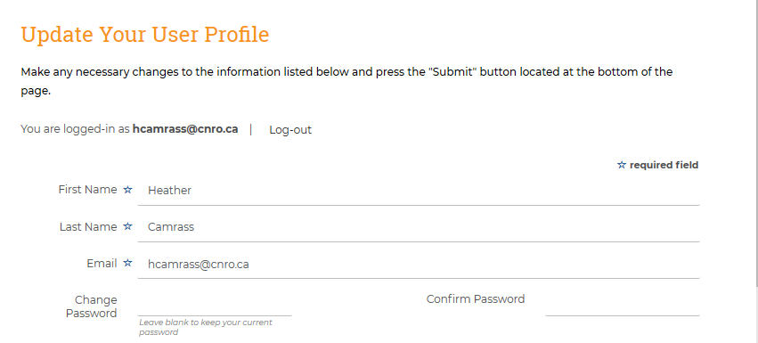
- Save the changes at the bottom of the screen

